**News introduction and instruction**

The skill used the create News function is almost same as what I used to create Customer FaQ. They both present the same function, just one for answering Customer Frequently asked questions, and one for allow manager announce Company news to customers.

Below shows how do I complete the task (All the code is included in News code folder[not runnable]) :

1. Run Rails command “$Rails generate model Run Rails command “$Rails generate model News title:string content:integer”
2. Run command “$rake db:migrate” to push updates to schema.
3. Include validation in model.

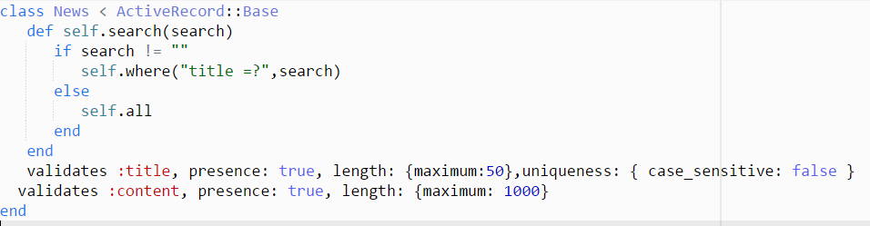

News Model

1. Include resources in routes.rb

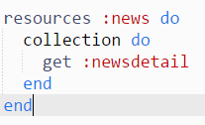

routes.rb : news resources declaration

1. Generate respective controller



News Controller

1. Generate respective html

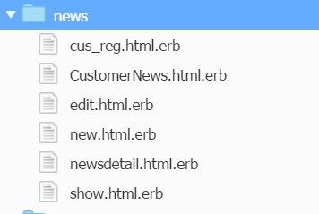

News html

1. Design interface with CSS.



News CSS